- Waterfall Methodology
The fundamental life cycle model for software development is the waterfall model. It is crucial since the conventional waterfall model serves as the foundation for all other software development life cycle models. The life cycle is divided into many segments according to the traditional waterfall paradigm. This model takes into account the possibility of starting a phase after the preceding phase has ended. That is, the input for the following phase will be the output of the previous one. As a result, the development process may be viewed as a waterfall’s sequential flow. The phases do not overlap in this instance (Geeks for Geeks, 2022).
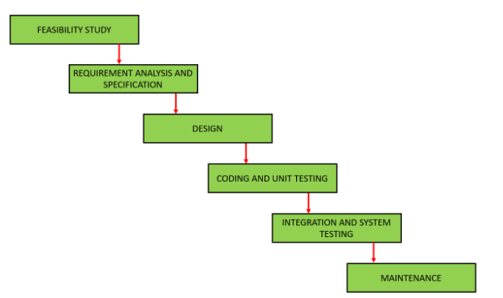

- Agile Methodology
It is a process in which the need and its solution emerge via the collaborative activity of teams and the client. The activity is divided into numerous phrases, and continual improvement and iteration are accomplished by communicating with stakeholders. Sprints are the names given to the divided portions (Young, 2013).
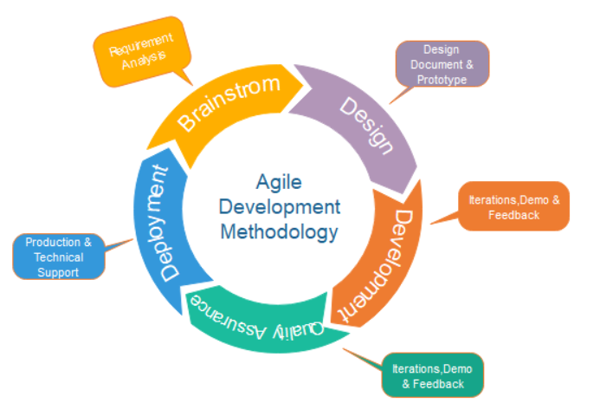

- Prototype Methodology
When users do not know the specific project needs ahead of time, the prototyping model is employed. In this approach, a prototype of the eventual product is created, tested, and improved based on consumer input until a final acceptable prototype is reached, which serves as the foundation for building the final product (Young, 2013).
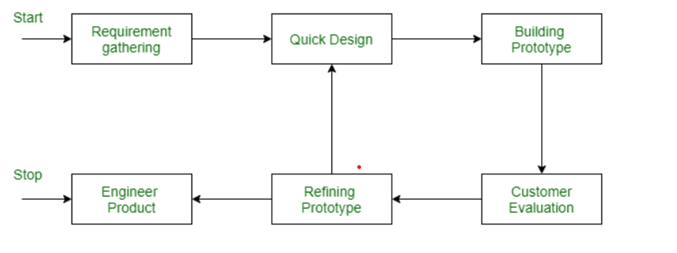
Figure 7: Prototype Methodology (Geeks for Geeks, 2022)

